**Topics discussed : Random variables, Gaussian Distribution**

**Random Variable:**

There are 2 types of Random Variables:

i) *Discrete Random Variable* : A discrete random variable has a countable number of possible values

ii) *Continuous Random Variable* : A continuous random variable takes on all the values in some interval of numbers.

**Gaussian Distribution/Normal Distribution:**

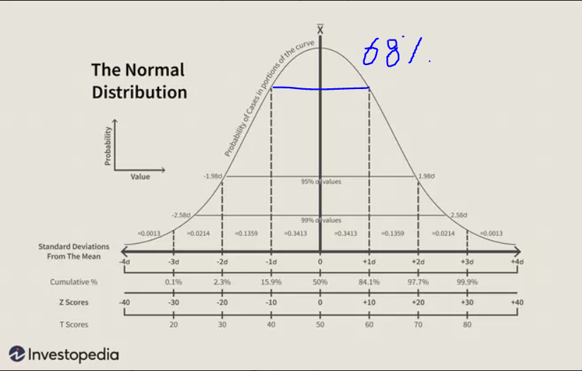

Mid is mean that is (µ).

Within one standard deviation 68% of values exist. (µ-sd ≤ x ≤ µ+sd)

Within two standard deviation 95% of values exist. (µ-2sd ≤ x ≤ µ+2sd)

Within third standard deviation 99.7% of values exist. (µ-3sd ≤ x ≤ µ+3sd)